Wania Zanib
23-NTU-CS-1289
BSAI 5th
Embedded IOT
Week 3 – Assignment 1

Code:
//Week 3 - Assisgnment
// Embedded IoT System Fall-2025

// Name: wania zanib Reg#: 1289

#include <Arduino.h>

//pins
#define LED1_PIN 2
#define LED2_PIN 15
#define SWITCH1_PIN 25
#define SWITCH2_PIN 14

#define DEBOUNCE_MS 50
#define DEBOUNCE_US (DEBOUNCE_MS * 1000UL)

//Timer Handles
hw_timer_t* debounceTimer1 = nullptr;
hw_timer_t* debounceTimer2 = nullptr;

//Debounce Flags
volatile bool debounceActive1 = false;
volatile bool debounceActive2 = false;

//Timer ISR for Switch 1
void ARDUINO_ISR_ATTR onDebounceTimer1() {
if (digitalRead(SWITCH1_PIN) == LOW) { //still pressed?
digitalWrite(LED1_PIN, !digitalRead(LED1_PIN)); //toggle LED1
}
debounceActive1 = false; //ready for next press
}

//Timer ISR for Switch 2
void ARDUINO_ISR_ATTR onDebounceTimer2() {
if (digitalRead(SWITCH2_PIN) == LOW) { //still pressed?
digitalWrite(LED2_PIN, !digitalRead(LED2_PIN)); //toggle LED2
}
debounceActive2 = false; //ready for next press
}

//External interrupt for Switch 1
void ARDUINO_ISR_ATTR onSwitch1ISR() {
if (!debounceActive1) {
debounceActive1 = true;
timerAlarm(debounceTimer1, DEBOUNCE_US, false, 0); //start one-shot timer
}
}

//External interrupt for Switch 2
void ARDUINO_ISR_ATTR onSwitch2ISR() {
if (!debounceActive2) {
debounceActive2 = true;
timerAlarm(debounceTimer2, DEBOUNCE_US, false, 0); //start one-shot timer
}
}

void setup() {
Serial.begin(115200);

//LEDs
pinMode(LED1_PIN, OUTPUT);
pinMode(LED2_PIN, OUTPUT);
digitalWrite(LED1_PIN, LOW);
digitalWrite(LED2_PIN, LOW);

//Configure switches with internal pull-ups
pinMode(SWITCH1_PIN, INPUT_PULLUP);
pinMode(SWITCH2_PIN, INPUT_PULLUP);

//Attached external interrupts (on button press)
attachInterrupt(SWITCH1_PIN, onSwitch1ISR, FALLING);
attachInterrupt(SWITCH2_PIN, onSwitch2ISR, FALLING);

//Created 1 MHz timers
debounceTimer1 = timerBegin(1000000);
debounceTimer2 = timerBegin(1000000);

//Attached debounce ISRs
timerAttachInterrupt(debounceTimer1, &onDebounceTimer1);
timerAttachInterrupt(debounceTimer2, &onDebounceTimer2);

Serial.println("System Ready — Press Buttons to Toggle LEDs");
}

void loop() {
// Nothing needed here; interrupts do all the work.
}

Output:
no input (initial state):
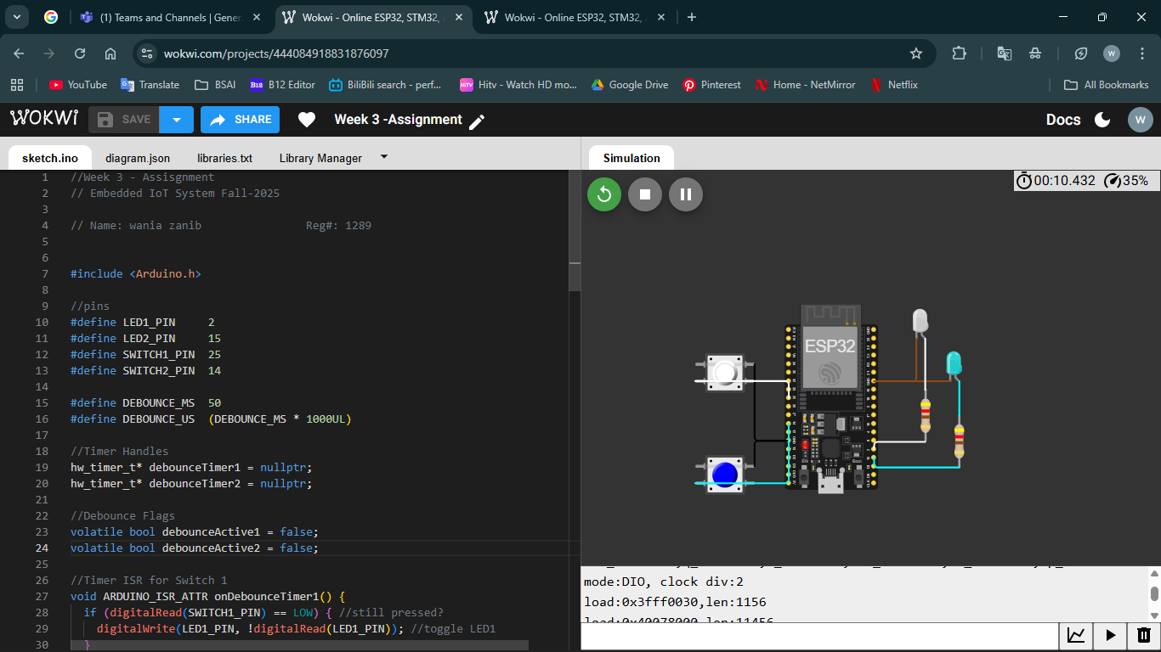

LED 1 turned on:
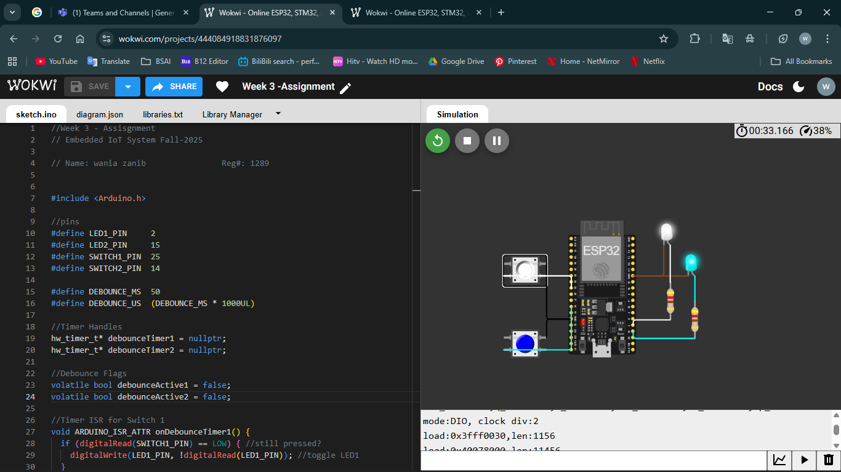
LED 2 turned on:
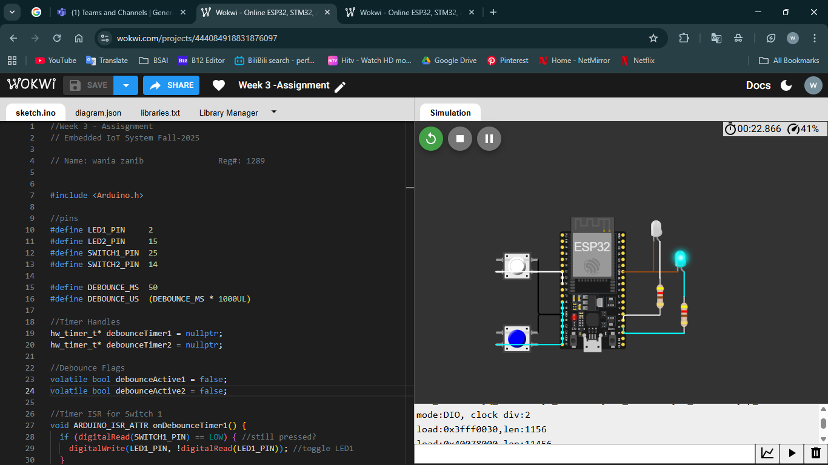

Project Link:
https://wokwi.com/projects/444084918831876097

